Syslab Journal
Name: Cameron Ake (or Cake you can call me Cake it’s fine my friends call me Cake)
Period: 4

Newest entries at the top!

Board link: https://m.media-amazon.com/images/I/B19d+VcYwWS.png

Last Pieces

5/2/2024
- I was sick today; for makeup I’m going to do the movie, since that was what I planned to do today. I haven’t actually been able to do that yet, since trying to do a presentation while sick is probably not the best idea.
- Journals are now done!

4/30/2024
- Presentations today! This week’s task is the movie, so I’ll be working on that. I’m going to plan for it, both logistics-wise and app-wise.
- I also feel crappy today because my allergies are being very annoying and I also might be getting sick (probably not but it’s possible??)

4/25/2024
- Plan: Finish poster (ideally with more results)!
- We had some presentations today, as well.
- Testing one FinalBot (Yellow) vs one DesignedBot (Green) vs two RandomBots (Blue/Red):
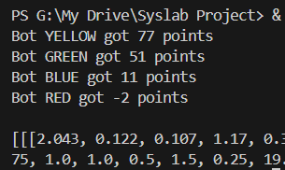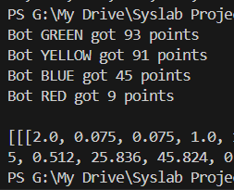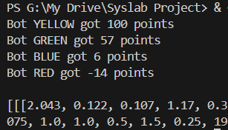
- I’m actually really proud of my poster it looks really nice???
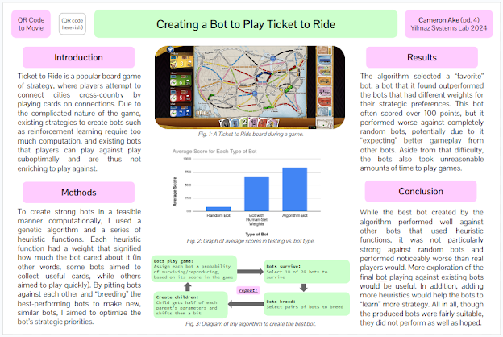
- Dr. Yilmaz said it was good, so I’m done with the poster!

4/23/2024
- Presentations today!
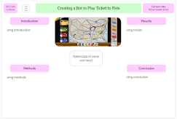
- Worked on my poster: I think I made a nice aesthetic layout!
- In future presentation, plan is to separate Methods into a Genetic Algorithm slide and a Heuristic slide
- I’ve successfully changed my presentation accordingly! Now, hopefully it’s all done. Plan for next class is to finish the poster (ideally with a few more results, too)!

Presentation and Demo

4/22/2024
- Plan: (over catch-up day) finish Methods slide and Results slide! (should take about 40 minutes, which is about how much time we have in class. I’ll do it during this class’s catch-up period!)
- Catch-up day
- Finished presentation!

4/18/2024
- Plan: Finish presentation!
- I’ve fixed the Why is Ours Better, the Novelty, the Impact, the RandomBots, the Limitations, the Conclusion, and created Final HeuristicBot Rationale Demo and HeuristicBot Game Demo slides!
- So it’s only Method and Results slides left… Results shouldn’t be too bad, since it’s essentially just writing what the algorithm outputted, how the bots tended to do, and how it seemed to really like one bot.

4/16/2024
- Out today for a college visit! This here is makeup
- Plan for today: have the bots play a game with the display. I’ll get more detailed data later on after making the presentation.
- UGH I SWEAR I FIXED THIS. Bug where the bot tries to draw a face-up locomotive. I think I fixed it this time but I genuinely hate this because now I need to start over my demo and the demo takes like an hour every time
- Okay, I finally have demo stuff done. I’ve demoed the HeuristicBot’s logic so people know why the final HeuristicBot is better than a simple RandomBot, and I’ve run a couple of games of final HeuristicBots vs. RandomBots.

4/15/2024
- Plan: Implement squared-heuristic thing or subtract-a-bit thing
- Fixed drive whatevers
- Since the 95-100% deadline is in a week and I’ll be traveling for half of it, I think the best use of my time here is to just work with what I have.
- I’m going to run one more repetition, and then I’m going to find whichever bot does the best out of that repetition and have two of its HeuristicBots play two RandomBots.
- OVERALL PLAN so I’m not staying up forever doing this or spending forever on this over the weekend (I have neither the energy nor the emotional capacity to do that):
  - Today: Get round-5 bots. Pick the two bots that did the best, maybe one from round 5 and one from wherever (maybe the one that got like 110 points earlier, idk). Maybe get a bit of work in on the presentation.
  - Makeup for tomorrow when I’m traveling: Have the bots play a game with the display. Also, have the bots play a few non-display games so I have some data.
  - Thursday: Finish up the presentation.
  - [Monday’s a catch-up day if I need it, but I’ve already planned to focus on a math thing that day because ✨we apparently still need homework even though I’ve learned a grand total of two things this entire semester across all of my classes, and only one of those things is in math✨. oops i may be a cynic]
  - Poster happens the following week (get more detailed data for this, probably); movie happens the week after; paper happens the week after.
- Update on the plan: this do-one-more-round thing is not happening. Instead I’ll use one from stage 4 and one from stage 1.
Bot from Stage 1: [2.043, 0.122, 0.107, 1.17, 0.37, 0.577, 2.495, 0.512, 25.836, 45.824, 0.176, 0.917, -0.029, -0.256, -0.092, 0.549, -0.867]
Bot from Stage 4: [2.043, 0.122, 0.107, 1.17, 0.37, 0.577, 2.495, 0.512, 25.836, 45.824, 0.176, 0.917, -0.029, -0.256, -0.092, 0.549, -0.867]
- So uh turns out they’re the same bot LOL. It carried over this far! Okay obviously the algorithm thinks this bot is GREAT so I’ll just use two copies of this bot versus two RandomBots.
- Actually no I’ll do my custom HeuristicBot versus this bot versus two RandomBots. That would be a nice comparison!
- Also finished slides 1-4 of the new presentation!

Implementing Algorithm

4/11/2024
- Plan: Continue to implement multi-round algorithm using data from new bot-storage method. Continue to work on paper. (I’d work on the presentation, but I don’t really feel like it and I’d rather do work I feel like doing now and do the presentation later when I feel like it.)
- Finished Background section of the paper!
- Got two more stages of the running working:
[2.043, 0.122, 0.107, 1.17, 0.37, 0.577, 2.495, 0.512, 25.836, 45.824, 0.176, 0.917, -0.029, -0.256, -0.092, 0.549, -0.867] 104
[2.248, 0.072, 0.127, 1.882, 0.27, 0.374, 1.797, 0.008, 9.78, 50.492, 0.168, 0.805, 0.608, -0.203, 0.018, 0.389, -0.892] 60
[1.495, 0.015, 0.04, 1.057, 0.176, 0.61, 1.363, 0.294, 10.959, 44.445, 0.021, 0.441, 0.657, 0.443, -0.082, 0.408, -0.678] 50
[2.127, 0.112, 0.086, 1.541, -0.142, 0.798, 1.341, 0.02, 12.907, 53.058, 0.266, 0.668, -0.064, 0.445, 0.049, 0.479, -0.456] 34
[2.281, 0.127, 0.093, 1.075, 0.497, 0.596, 2.03, 0.456, 20.077, 46.516, 0.679, 0.956, 0.097, -0.248, 0.324, 0.578, -0.868] 82
[2.132, 0.034, 0.028, 1.065, 0.059, 0.797, 1.444, 0.331, 12.827, 52.075, -0.041, 0.518, 0.137, 0.551, 0.006, 0.331, -0.595] 59
[1.595, 0.124, 0.106, 1.495, 0.369, 0.475, 0.653, 0.458, 23.867, 45.512, 0.149, 0.719, -0.237, 0.259, -0.184, 0.514, -0.915] 21
[0.841, 0.078, 0.057, 1.965, 0.308, 0.455, 1.614, 0.103, 11.678, 49.468, -0.126, 0.847, 0.294, -0.445, -0.443, 0.615, 0.219] 14
[3.594, 0.085, 0.141, 1.219, 0.147, 0.452, 2.649, 0.188, 20.951, 49.461, 0.786, 0.756, 0.44, -0.1, 0.268, 0.19, -0.938] 76
[3.706, 0.095, 0.072, 1.2, 0.066, 0.75, 2.873, 0.179, 26.913, 50.007, 0.776, 0.705, 0.29, -0.199, 0.17, 0.098, -0.898] 57
[3.368, 0.09, 0.158, 1.068, 0.356, 0.548, 2.178, 0.197, 22.207, 46.878, 0.224, 0.526, 0.022, 0.645, -0.169, 0.169, -0.769] 49
[1.945, 0.096, 0.099, 2.111, 2.15, 0.544, 0.056, 0.058, 26.158, 54.131, 0.649, 0.078, -0.38, 0.129, -0.464, -0.072, -0.344] 12
[3.721, 0.05, 0.087, 0.787, -0.115, 0.828, 1.685, 0.387, 20.001, 53.293, 0.238, 0.467, 0.129, -0.191, -0.349, -0.141, -0.485] 85
[2.284, 0.019, 0.113, 1.937, -0.024, 0.567, 1.007, -0.044, 10.494, 43.801, -0.093, 0.914, 0.588, 0.349, -0.222, 0.367, -0.642] 53
[1.75, 0.053, 0.051, 1.299, 0.263, 0.445, 1.684, 0.295, 8.731, 50.384, 0.229, 0.332, 0.35, -0.178, -0.125, 0.434, -0.914] 48
[2.111, 0.083, 0.041, 1.017, -0.02, 0.806, 0.376, 0.162, 14.717, 51.143, -0.054, 0.663, 0.062, 0.516, 0.067, 0.268, -1.16] 30
[2.053, 0.13, 0.058, 2.047, 0.289, 0.62, 1.673, 0.15, 18.17, 46.275, 0.135, -0.115, 0.161, 0.042, 0.083, 0.295, -0.9] 77
[1.746, 0.048, 0.077, 0.844, 1.3, 0.733, 0.432, 0.089, 18.078, 50.135, 0.793, 0.645, 0.409, 0.624, 0.094, 0.485, -0.454] 41
[1.474, 0.091, 0.067, 1.688, 0.208, 0.67, 1.134, 0.08, 26.416, 54.406, 0.127, 0.795, -0.418, 0.547, -0.36, 0.208, -0.257] 19
[1.504, 0.129, 0.093, 2.076, 2.227, 0.59, -0.093, 0.09, 11.564, 44.85, 0.554, 0.172, 0.805, 0.111, -0.015, -0.2, -0.618] 19

4/9/2024
- Wasn’t here today (college visits!)
- Plan: Continue to implement multi-round algorithm using data from new bot-storage method. Continue to work on paper.
- Going to run it, but I’m also going to have it output the bots immediately after breeding, since that’s the quick part. That way, I can tell if it’s actually using 24 or if I was just being stupid last time.
  - Yeah, there are 20 bots; I don’t really know what happened.
- Also, on this note, I’m going to round all the new bots to three digits, which I hadn’t done before (it’s probably easier numerically to store multiplication and whatever for that, making the program a tad faster).
- There we go! That’s all done; good to go. Now, I’ll actually run the algorithm.
Repetition 3 results:
[3.594, 0.085, 0.141, 1.219, 0.147, 0.452, 2.649, 0.188, 20.951, 49.461, 0.786, 0.756, 0.44, -0.1, 0.268, 0.19, -0.938] 82
[2.248, 0.072, 0.127, 1.882, 0.27, 0.374, 1.797, 0.008, 9.78, 50.492, 0.168, 0.805, 0.608, -0.203, 0.018, 0.389, -0.892] 76
[2.132, 0.034, 0.028, 1.065, 0.059, 0.797, 1.444, 0.331, 12.827, 52.075, -0.041, 0.518, 0.137, 0.551, 0.006, 0.331, -0.595] 18
[1.945, 0.096, 0.099, 2.111, 2.15, 0.544, 0.056, 0.058, 26.158, 54.131, 0.649, 0.078, -0.38, 0.129, -0.464, -0.072, -0.344] 2
[1.973, 0.052, 0.083, 0.931, 0.226, 0.696, 1.444, 0.045, 20.255, 45.388, 0.231, 0.695, 0.251, 0.524, -0.016, 0.48, -0.755] 71
[2.043, 0.122, 0.107, 1.17, 0.37, 0.577, 2.495, 0.512, 25.836, 45.824, 0.176, 0.917, -0.029, -0.256, -0.092, 0.549, -0.867] 71
[1.845, 0.129, 0.078, 1.679, 0.343, 0.607, 1.449, 0.033, 11.308, 45.393, 0.195, 0.708, 0.612, 0.475, -0.058, 0.34, -0.737] 54
[1.941, 0.123, 0.07, 2.148, 1.353, 0.637, 0.506, 0.128, 19.994, 51.235, 0.702, -0.06, 0.228, 0.124, 0.045, 0.423, -0.599] 31
[3.022, 0.11, 0.087, 0.975, 0.114, 0.71, 2.149, 0.168, 27.838, 46.358, 0.157, 0.649, -0.081, 0.726, -0.23, 0.246, -0.911] 99
[2.281, 0.127, 0.093, 1.075, 0.497, 0.596, 2.03, 0.456, 20.077, 46.516, 0.679, 0.956, 0.097, -0.248, 0.324, 0.578, -0.868] 52
[1.595, 0.124, 0.106, 1.495, 0.369, 0.475, 0.653, 0.458, 23.867, 45.512, 0.149, 0.719, -0.237, 0.259, -0.184, 0.514, -0.915] 27
[3.821, 0.066, 0.089, 1.924, 1.68, 0.106, 0.371, 0.357, 12.533, 43.247, 0.579, 1.035, 0.244, 0.657, 0.176, -0.137, -0.023] 18
[1.495, 0.015, 0.04, 1.057, 0.176, 0.61, 1.363, 0.294, 10.959, 44.445, 0.021, 0.441, 0.657, 0.443, -0.082, 0.408, -0.678] 92
[1.581, 0.094, 0.106, 1.15, 2.297, 0.865, 0.649, 0.327, 26.452, 47.298, 0.377, 0.277, -0.811, -0.22, -0.072, -0.205, -0.886] 47
[1.549, 0.132, 0.12, 2.177, 1.365, 0.484, 0.214, 0.043, 16.309, 55.22, 0.714, 0.074, -0.038, 0.046, -0.325, 0.384, -0.325] 35
[2.127, 0.112, 0.086, 1.541, -0.142, 0.798, 1.341, 0.02, 12.907, 53.058, 0.266, 0.668, -0.064, 0.445, 0.049, 0.479, -0.456] 21
[3.939, 0.084, 0.075, 1.023, 0.22, 0.952, 0.258, 0.222, 20.044, 50.211, 0.152, 0.769, 0.39, -0.081, -0.488, -0.271, -1.07] 43
[0.841, 0.078, 0.057, 1.965, 0.308, 0.455, 1.614, 0.103, 11.678, 49.468, -0.126, 0.847, 0.294, -0.445, -0.443, 0.615, 0.219] 29
[1.903, 0.063, 0.123, 1.986, 1.9, 0.463, 0.075, 0.045, 24.373, 51.54, 0.135, 0.166, -0.828, -0.183, 0.05, 0.397, -0.81] 24
[4.333, 0.095, 0.148, 0.715, 1.889, 0.503, 2.863, 0.411, 9.142, 50.353, 0.666, 0.339, -0.224, 0.452, 0.274, 0.169, -0.568] 0

- The bots are still mostly not great. I’m thinking that, instead of simply operating on the number of points to determine probability, I should use the score squared to determine probability of selection. That way, bad bots that get ~20 points get 400, mediocre bots with ~60 points get 3600, and great bots with ~100 points get 10000—a better dichotomy. (This would be a 2.6%/25.7%/71.4% split, as opposed to an 11.1%/33.3%/55.5% split—i.e. a bit more in-line with what I’m looking for. I could also try doing the genetic algorithm with replacement.) I could also make it so b

4/4/2024
- Plan: Continue to implement multi-round algorithm using data from new bot-storage method. Maybe begin working on paper, too?
- We had our pizza party today!
- Last time, fifteen minutes was not enough time to run a round. My hope is that this time, I’ll have enough time to run another round and see if there’s noticeable improvement.
- I made the paper and wrote the intro and half of the background. I also ran the next round, but somehow it outputted at least 24 bots for the 20 (I had to cut it short).

4/3/2024
- Plan: Continue to implement multi-round algorithm using data from new bot-storage method.
- Apparently I forgot to make a method that would actually pick up data from existing files…
- Solved several bugs along the way (ugh I hate reading files) but I have it working! Storage should all be working now.
- Continuing to run now—I only have 15 minutes left, but I’ll hopefully be able to see analyze-able progress

Making Genetic Algorithm

3/21/2024
- Plan: Implement several rounds of algorithm!
- The algorithm could take less time, but I’m not exactly sure how I could prune it. To be honest, I could just randomly remove like half the possible routes to take on a given turn when it’s searching for possible moves—it probably doesn’t reeeeeally matter if the bot waits a turn to play trains somewhere, and the distance_reduction method it runs for every single possible move is definitely the biggest time annoyance.
  - On that note, I want to review my distance_left_to_span method (key in using the distance_reduction method) to figure out if there’s some way I could make it more time efficient.
- Fixed bot-output method to output points as well so I’d be able to monitor progress. Made big new method to do the actual algorithm! I decided to output each step’s bots with their scores in a file so I could see how the algorithm is doing for each step. With this, I’ll finally be able to watch the algorithm do its thing!
  - Upon testing this method, it seems to work - every step, it makes a file of the bots. This is perfect - I can run it every class and simply use the old files it creates so I can pick up where I left off!
- Here’s what each intermediate file looks like:
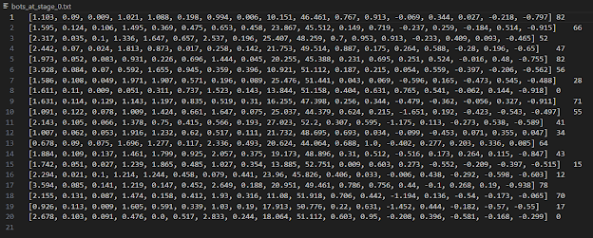
- I noticed in the second round of bots that the bots that did truly horribly (0 or below—negative is counted as 0 for the purposes of the program; otherwise it would mess with the cumulative summation and indexing) both had some negative value for a heuristic that really wasn’t supposed to be negative. I’d code something in to keep that from happening, but honestly, if something that bad happens, the bots are basically removed from the bot gene pool on their own immediately anyway.
- The method is definitely working! On the second set of newly generated bots, one bot got 114 points, by far the highest I’d seen so far. Most notably, it had a high value for the “bias” value of a face-up card draw, meaning face-up card draws were seen as particularly good (which tracks), and it had a low value for “bias” of playing trains and it had a high value for the weight of cards-away-from-ticket-drop-when-you-play-trains-somewhere, both meaning this bot was very against playing when it didn’t see a need to. (Weight list is below!)
[2.043, 0.122, 0.107, 1.17, 0.37, 0.577, 2.495, 0.512, 25.836, 45.824, 0.176, 0.917, -0.029, -0.256, -0.092, 0.549, -0.867] 114

3/19/2024
- Plan: Test breeding-and-mutation part of the algorithm, see if the new bots are noticeably better. The actual creation of the bots might take longer than expected—I’m not sure how to improve time efficiency, though, besides pruning some routes.
- Made a method to sanitize the gazillion bots and trim it and make it remotely visible. That way, I can test the breeding-and-mutation part and make sure it works. Which it probably won’t, considering I wrote it all in one go.
- Testing: there were twenty input bots and there somehow managed to be seventeen output bots. What????
- Bug: Data structures fail. Happened three times - I had to reorganize the tuple/list structure of each bot.
- Bug: misinterpreted “index” variable as 0-1 instead of an int from 0 to max score
- Bug: I had a “score_total” variable that I was using to scale the max score. I wasn’t updating it when I was removing bots, meaning the max score was too high and sometimes it couldn’t find a bot!
- So now that that’s all done, I have twenty bots and I’m chilling more… but now I need to make sure the new bots actually come from the old bots.
- Bug: Was using archaic copy of a list that was being used for something else to calculate max score for breeding bots.
- The preserved bots look good! That was the easy part, though. I need to find some way to ensure each of the baby bots is a mutated copy of some pair of old bots.
  - Aaaand I cannot tell. I’m going to set the learning rate to 0 and identify the bots!
- With learning rate 0, I can tell they’re all children of the past bots. Yay! We’re good! The parts of the algorithm are done… now it’s time to attempt to implement it.

3/18/2024
- Plan: Test breeding-and-mutation part of the algorithm, see if the new bots are noticeably better. The actual creation of the bots might take longer than expected—I’m not sure how to improve time efficiency, though, besides pruning some routes.
- Catch-up day today!

3/14/2024
- Plan: Continue working on the genetic algorithm!
- Bug: number of games was being weird and being a float. I forced it to be an int !! definitely no problems here nope !!
- Bug: mutation algorithm wasn’t working. It turned out the adding-random-value part was only adding to a constant, not the list value itself
- Bug: one of my files was printing instead of returning 💀
- I made a new file called storage.txt. Each round of bots-playing-games takes like half an hour due to all the searching involved in the heuristics, so I want to store the output for future class periods in case I ever run a round of bots but don’t breed or something.
- Setting learning_rate to 0.25 for now…
- Running collection_of_games method first with 20 HeuristicBots with trainable weights—my hope is I can test both it and the breeding method
- We reviewed what we’d talked about during the 60% presentation
- Time-wise with the algorithm, things are super variable. I ran one set of games in about 20 or 30 minutes and another set of games took like an hour to only get 60% of the way through.
- Results of the first (quicker) set of games! These are all HeuristicBots, but their heuristics are randomized. You can see how some of them end up doing much better than others simply because of the heuristics. I’ve saved the output values and I’ll create new bots tomorrow!
BBot GREEN got 82 points
Bot RED got 66 points
Bot BLUE got 52 points
Bot YELLOW got 47 points

Bot GREEN got 82 points
Bot BLUE got 56 points
Bot YELLOW got 28 points
Bot RED got -21 points

Bot RED got 71 points
Bot BLUE got 55 points
Bot YELLOW got 41 points
Bot GREEN got 34 points

Bot RED got 64 points
Bot YELLOW got 43 points
Bot BLUE got 15 points
Bot GREEN got 12 points

Bot RED got 78 points
Bot GREEN got 70 points
Bot BLUE got 17 points
Bot YELLOW got -5 points

3/12/2024
- Plan: All the heuristic values have been initialized well now. It’s time to start figuring out and working on the genetic algorithm!
- Algorithm Overview (Plan): Play N games of four bots each. The number of points each bot got (if they got negative, they’ll be accounted for as 0 points) divided by the total sum of points will be the probability of them being chosen as a parent. Each pair of parents will produce two children, with each child getting some random distribution of their parents’ weights. The children’s weights will then mutate. With mutation rate 𝛼 = 0.1 (can be changed), each weight will change some random number from -𝛼 to 𝛼 times the difference between the max and min initial values of the heuristic. (So 𝛼 is a range, not a hard-set amount things will change.) This will then repeat R times.
- Created a variable PRINT_THINGS and put it in eeeeeeeeeverywhere I print something to control whether or not things are being printed (I do NOT want to read a gazillion print statements for every game the bots in the genetic algorithm play)
  - Had several bugs that I had to fix, plus had to change it so it outputs the results of each game as well as the Nothing
  - Another bug: needed to declare a variable for each bot I was removing from the queue
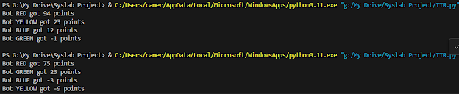
- As expected, Red (the HeuristicBot) is absolutely demolishing the RandomBots!
- One thing I’m noticing: some games take way longer than others with the HeuristicBot. I guess depending on which tickets it takes or how many cards it is, sometimes it’s good-case and sometimes it’s a worst-case thing?
- Had to configure the bots_play_game method to return the weights and scores of each bot, plus refigure the while loops and queue extraction methods so they would be compatible with this strategy and not simply throw out whatever they get
- Created mechanism to initialize weights with several lists and a lambda function to initialize new weights whenever we want
- Wrote collection_of_games method to run all the N games in a given round. I haven’t tested it or written anything with the genetic algorithm itself yet, but it’s ready now! I have a method that does a round of games without breeding and outputs weights and points for each bot, so next I make the breeding and mutating method

3/11/2024
- Plan:
  - Fix bug where HeuristicBot thinks it can do things it can’t (like playing trains after drawing a card). (Should take Monday)
  - Since we’re not doing presentations until April, I don’t think I need to make a display with these HeuristicBots—the goal here is to get the genetic algorithm working! Start work on the genetic algorithm Tuesday!
- Working!
- Coded something to potentially fix this problem. Still observing HeuristicBot.
  - Bot is still weighting longest-route too much
- I changed several initializing values, most notably making distance_from_route_change much more important and making the bot less willing to play trains. The HeuristicBot performs much better now!

Building Final Heuristic

3/7/2024
- Plan:
  - Step 4: See how good the bot is and if it's noticeably better than a RandomBot. If not, something's wrong.
  - Step 5: Develop the genetic algorithm for real!
- First thing (from last time): Add another weight and heuristic that reflects not being able to draw cards—simply the act of playing trains will be a penalty of some sort.
- Actually, better idea! I’m going to change L’s heuristic to num_cards_drawn and have L be positive. That way, the computer associates more cards with being better.
- I could also just add another constant value (similar to N) for every type of move (face-up, card-draw, ticket-taking, train-playing) to simulate the idea of the computer preferring one type of move over the others! I like that idea, and I’ll do it. They’ll work like bias would in a neural network! Look at me, I’m applying ML knowledge wow ✨
- New heuristic details:
value_of_move (higher is better) (notable things in pink highlight, explained below) = avg(A * distance_reduction for each ticket) + B * longest_route_change + C * longest_route_diff + D * points_gained_from_playing + E * ticket_point_change + avg(F * cards_away_from_ticket_change for each ticket), if taking card - G * num_trains_played_in_move + H * (ticket_taking_boost + J * tickets_all_done - K) + L * num_cards_drawn + avg(M * playing_CAFT_change for each ticket - a negative value) + N + P * drawing + Q * tickets + R * faceup + S * playing
- G * num_trains_played is negative to penalize the player for wasting trains
- H * (ticket_taking_boost + J * tickets_all_done - K) means that ticket_taking_boost can be trained to be negative if K is large
- L * taking_locomotive is negative to penalize the player for spending the entire turn on taking a locomotive
- N is the default value of some throwaway move that does absolutely nothing
- The following values are based on ‘how many points would I expect this value to get the player’:
- Initialize A around the range (0, 4)
- Initialize B around the range (0, .15)
- Initialize C around the range (0, .15)
- Initialize D around the range (0, 2)
- Initialize E around the range (0, 2)
- Initialize F around the range (0, 1)
- Initialize G around the range (0, 3)
- Initialize H around the range (0, 0.5)
- Initialize J around the range (10, 28)
- Initialize K around the range (44, 54)
- Initialize L around the range (0, 1)
- Initialize M around the range (0, 1)
- Initialize N around the range (-2, 1)
- Initialize PQRS around the range (-.6, .6) with S around (-1, .2)
- Bug: for some cases, move value was just returning a random value rather than the actual heuristic. Fixed that!
- THE BOTS ARE OFFICIALLY SMART! In my first test, the HeuristicBot, as contrasted with the RandomBots, took routes that were clearly conducive to getting its tickets.
  - Potential bug: Often, the HeuristicBot says taking some given route is a heuristic of like 11 even when it doesn’t actively give it either a train ticket or the longest route (which would be the only serious cases where that would be true). My guess is just that there are so many heuristics that they've all added together and made a mess of things. Fixing a few values accordingly.
    - I’m also going to see what it actually says for the values of some of these heuristics, since they seem fairly sketchy. The card-drawing heuristics all seem to work just fine, since the bot is drawing the cards that would make sense for it to draw.
  - Bug: Because of the longest_route_change method, the bot immediately wants to play trains quickly… I should add some sort of thing to affect the longest_route_change piece, probably based on the number of trains of the lowest person. For now I think I’ll just make longest_route_change only happen when the number of trains left with the lowest player is 20 or less.
    - Okay, that would be particularly hard, so I made it so that it only kicks in when the new longest route value will be >10. This means it’ll only start caring about that when the value is actually possibly notable. I’ll also adjust the weight so it doesn’t care as much about it.
    - Okay, I think this bug is fixed! It’s not obsessive about constantly playing trains anymore.
  - Bug: The bot still considers moves it can’t make (like playing after drawing a card). I need to fix that.
  - Bug: Wrong number of values provided to the bot. Fixed that!
  - Bug: If someone besides this player had played on a route, cards_away_from_ticket had no way to process it. Absolutely no idea how that never came up for so long, but I fixed it.
- First full game with HeuristicBot versus three RandomBots has its output below. Take a wild guess which bot has any intelligence at all…
  - I will say, the bot still seems to care way too much about getting the longest route. I’ve adjusted the values accordingly.
- Notes for the future: If I want to make it a bit more time-efficient, I can see if I can prune playing trains where it doesn’t make a ticket distance smaller or add to the route size. Most of the heuristic calculations are from playing-trains options, as ticket-taking and card-taking don’t have many options.

--------------------------------------
The game has ended!
--------------------------------------

--------------------------------------
Bot BLUE got 40 points plus -32 ticket points
with tickets: {('Chicago', 'Santa Fe'): 9, ('Los Angeles', 'Chicago'): 16, ('Calgary', 'Salt Lake City'): 7}
ticket ('Chicago', 'Santa Fe') NOT connected.
ticket ('Los Angeles', 'Chicago') NOT connected.
ticket ('Calgary', 'Salt Lake City') NOT connected.
with longest route ['New York', 'Montreal', 'Toronto', 'Chicago', 'Saint Louis']
of length 12
getting 8 TOTAL POINTS
--------------------------------------

--------------------------------------
Bot YELLOW got 63 points plus -30 ticket points
with tickets: {('Vancouver', 'Santa Fe'): 13, ('San Francisco', 'Atlanta'): 17}
ticket ('Vancouver', 'Santa Fe') NOT connected.
ticket ('San Francisco', 'Atlanta') NOT connected.
with longest route ['Las Vegas', 'Los Angeles', 'San Francisco', 'Salt Lake City']
of length 10
getting 33 TOTAL POINTS
--------------------------------------

--------------------------------------
Bot GREEN got 33 points plus -36 ticket points
with tickets: {('Chicago', 'New Orleans'): 7, ('Helena', 'Los Angeles'): 8, ('Duluth', 'El Paso'): 10, ('New York', 'Atlanta'): 6, ('Kansas City', 'Houston'): 5}
ticket ('Chicago', 'New Orleans') NOT connected.
ticket ('Helena', 'Los Angeles') NOT connected.
ticket ('Duluth', 'El Paso') NOT connected.
ticket ('New York', 'Atlanta') NOT connected.
ticket ('Kansas City', 'Houston') NOT connected.
with longest route ['Helena', 'Seattle', 'Vancouver']
of length 7
getting -3 TOTAL POINTS
--------------------------------------

--------------------------------------
Bot RED got 57 points plus 25 ticket points
with tickets: {('Los Angeles', 'New York'): 21, ('Denver', 'El Paso'): 4}
ticket ('Los Angeles', 'New York') connected!
ticket ('Denver', 'El Paso') connected!
with longest route ['Charleston', 'Atlanta', 'Raleigh', 'Pittsburgh', 'Chicago', 'Saint Louis', 'Nashville', 'Little Rock', 'Oklahoma City', 'Santa Fe', 'Phoenix', 'El Paso', 'Santa Fe', 'Denver', 'Kansas City', 'Oklahoma City']
of length 37
getting 92 TOTAL POINTS
--------------------------------------

3/4/2024
- Plan:
  - Step 3: Test new play_trains and best_move. (I'll probably get somewhere around here today)
  - Step 4: See how good the bot is and if it's noticeably better than a RandomBot. If not, something's wrong.
  - Step 5: Develop the genetic algorithm for real!
- Currently trying to figure out how and why the bots are outputting “gray” cards when those don’t even exist.
- THIS IS OFFICIALLY THE MOST INFURIATING BUG EVER. IT IS PRINTING [‘gray’, ‘gray’] AND I HAVE NO IDEA WHY. THERE ARE NO PRINT STATEMENTS. I HAVE TEDIOUSLY, PAINSTAKINGLY SEARCHED ALL FORTY-TWO PRINT STATEMENTS IN MY HEURISTICBOT CODE FOR ANY HINT OF PRINTING [‘gray’] OR [‘gray’, ‘gray’] AND I HAVE GOTTEN NOWHERE IN AN ENTIRE BLOCK
- Okay finally it is 3:50 PM and I found it. It was printing out the *potential colors to take*—presumably a leftover print statement from testing somewhere. So routes with one gray route available to take were [‘gray’] (even if they were 5 or 6 long) and routes with two gray routes available were [‘gray’, ‘gray’].
- I’ve noticed that the bot seems to want to play immediately. I may have to adjust the heuristic weight for train cars being used accordingly?
  - Plan for next time: Instead of that, I’m going to add another weight that reflects not being able to draw cards—simply the act of playing trains will be a penalty of some sort.
- The methods aren’t being error-ful though! It’s working officially!

2/29/2024
- Plan: (for the next several classes)
  - Step 1: Redo the heuristic formula and add any new weights accordingly.
  - Step 2: Come up with values for the heuristics that I think are good.
  - Step 3: Test new play_trains and best_move. (I'll probably get somewhere around here today)
  - Step 4: See how good the bot is and if it's noticeably better than a RandomBot. If not, something's wrong.
  - Step 5: Develop the genetic algorithm for real!
- We discussed what we’d do for the next party
- Developing new heuristic:
Here is the least complicated heuristic function calculation (if I have time, I’ll improve on this later on, but these are the values that absolutely need to be in the heuristic for things to work):
value_of_move (higher is better) (notable things in pink highlight, explained below) = avg(A * distance_reduction for each ticket) + B * longest_route_change + C * longest_route_diff + D * points_gained_from_playing + E * ticket_point_change + avg(F * cards_away_from_ticket_change for each ticket), if taking card - G * num_trains_played_in_move + H * (ticket_taking_boost + J * tickets_all_done - K) - L * taking_locomotive + avg(M * playing_CAFT_change for each ticket - a negative value) + N
- G * num_trains_played is negative to penalize the player for wasting trains
- H * (ticket_taking_boost + J * tickets_all_done - K) means that ticket_taking_boost can be trained to be negative if K is large
- L * taking_locomotive is negative to penalize the player for spending the entire turn on taking a locomotive
- N is the default value of some throwaway move that does absolutely nothing
- The following values are based on ‘how many points would I expect this value to get the player’:
- Initialize A around the range (0, 2)
- Initialize B around the range (0, 2)
- Initialize C around the range (0, 2)
- Initialize D around the range (0, 2)
- Initialize E around the range (0, 2)
- Initialize F around the range (0, 1)
- Initialize G around the range (0, 3)
- Initialize H around the range (0, 0.5)
- Initialize J around the range (10, 28)
- Initialize K around the range (44, 54)
- Initialize L around the range (0, 1)
- Initialize M around the range (0, 1)
- Initialize N around the range (-2, 1)
- Testing play_trains and heuristic:
  - Bug: method for finding player who’d played most trains didn’t account for if no one had played trains. Fixed that.
  - Bug: removing this bot from a list of the bots wasn’t working because it was using the pointer for the bot. I figured out I could work around this by using the _str_ method.
  - Bug: I was using spaces to create a general case of the bot making a move, but some of the cities have spaces in them (e.g. “Kansas City”), so it would read “play Kansas City Omaha” (play trains from Kansas City to Omaha) as playing trains from Kansas to City Omaha
  - Very funny bug: I intentionally made my heuristic positive=better so it’s more intuitive and I planned to negate the heuristic when adding things to the priorityQueue, but I forgot. So now the bot makes the absolute worst possible move
  - Bug: When K < 45, it makes taking extra tickets at the start a “good move”. I need to change the possible values of K accordingly.
  - Next Bug: for some reason, it’s saying it played gray trains, which isn’t possible. Fix that.

2/27/2024
- Plan: Fix CAFT_change_from_playing. If time allows, test the heuristic and best_move function!
- Changed CAFT_change_from_playing to adopt played-trains addition
  - Bug: I was using the old dist_left to find cards away from ticket
  - Genuinely like seven consecutive bugs where the deepcopy wasn't going deep enough and it wasn't returning the board to what it was supposed to be before the method (I changed the board in the method and tried to fix it in the method). Finally fixed it
- Finally finished method! Tested it and it works now!
- All heuristic functions are finally done... Now I can make my first heuristic bot. But before that, I need to update play_trains to work with the heuristic function.
- Finished play_trains that now works with heuristic function! Haven't gotten time to test it yet, though.
- Future Heuristic: playing on gray spaces versus playing a specific color (I'm not sure which is better)
- Future Heuristic: penalty for number of locomotives played in move

2/26/2024
- Plan: Add cards_away_from_ticket_change for playing trains into the heuristic. If time allows, test the heuristic and best_move function!
- Wrote the playing-trains cards portion and finished CAFT_change_from_playing method as described earlier - it’s going to output a negative or 0 value, so in the heuristic, it’ll simply get added.
- Testing the CAFT_change_from_playing function:
  - Okay, so I found an important bug here: I need to also update the board in this function or else it doesn’t work effectively (it thinks playing every card is automatically a loss). I’ll fix that next class!

2/22/2024
- Plan: finish working on the overall heuristic function!
- Fixed heuristic formula to accommodate longest_route_diff (see 2/8/2024 entry for full formula and plan)
- Fixed bug where tickets_all_done wasn’t returning True if the tickets were all done, LOL
- Wrote the heuristic case for ticket-taking! Two more to go (face-up draw, playing trains)
- Adjusted heuristic formula to divide the parts that are for-each-ticket by the number of tickets so it’s taking an average rather than a raw sum
- Wrote the heuristic case for face-up-drawing! Just playing to go (although playing is probably going to be the most complicated).
- Wrote the heuristic case for playing trains! So it’s nominally done, but I realized along the way I also want to add a cards_away_from_ticket_change for playing on some route. That’s my next step, then I test the heuristic and the best_move function!

Assorted Smaller Heuristics

2/20/2024
- Plan: test longest_route_change and start working on the overall heuristic function!
- Longest_route_change works!
  - Tested it out on a couple cases—I had a bug where the test case itself was wrong, but I fixed that eventually
- It’s overall heuristic making time! I have absolutely no idea how long this will take, so that’ll be ✨fun✨
- Set up the heuristic-calculation method, made a find-best-move method nestled within turn-taking method complete with priority queue (and I tested it!)
- Made the heuristic method work for draw-card turn choice! Need to adapt to other potential move choices next.

2/15/2024
- Plan: work on the other two heuristics! (If I keep up this pace, I might have bots by the next presentation… we’ll have to see…)
  - longest_route_change (points gained from gaining longest route if we make this move) (wouldn’t account for other players losing points—it’s probably not worth the time it’d take to do so)
  - taking_locomotive (1 if the move is to take a face-up locomotive)
  - I don’t think I can do taking_locomotive until after I’ve actually created the main heuristic function, just because it’s a really simple function but it relies on actually being given a move, which I haven’t coded yet. I’m going to do the longest_route_change function first and see if I get to actually making the heuristic function! This will be the first class period where I might actually start working on the main heuristic…
- Dr. Yilmaz talked about TJStar and the project paper
- I’ve brainstormed and added a new heuristic: longest_route_diff. This is just the difference that a given move would make to the longest route this player has; it’d incentivize the player to keep making moves that line up with each other in the first place (rather than only moves that get the player in the lead longest-route wise)
- I both coded and tested out longest_route_diff and it works!
- Also trying to finish longest_route_change today. If so, next class I can start work on the actual heuristic function!
  - I finished coding the method, but I haven’t gotten a chance to test it yet. That’s my first priority for tomorrow!

2/13/2024
- Plan: work on the other four heuristics! (If I keep up this pace, I might have bots by the next presentation… we’ll have to see…)
  - longest_route_change (points gained from gaining longest route if we make this move) (wouldn’t account for other players losing points—it’s probably not worth the time it’d take to do so)
  - ticket_point_change
  - num_trains_played_in_move (for value-of-a-train-car calculations)
  - taking_locomotive (1 if the move is to take a face-up locomotive)
- Had some trouble setting up Google Drive. Sometimes Google Drive just ✨does that✨. Also, libraries were being grumpy today.
- Finished num_trains_played_in_move! Only one bug, where I wrote a 1 instead of a 0.
- Finished ticket_point_change!
  - Also found an opportunity to test it in conjunction with several other methods like distance_reduction and dist_left_to_span
    - Bug: hadn’t accounted for new output type of dist_left_to_span
    - Another bug: had put methods before initializing tickets, so ticket_point_change was just outputting 0
  - Fixed bugs right before class ended!

2/12/2024
- Plan: work on the other five heuristics! (If I keep up this pace, I might have bots by the next presentation… we’ll have to see…)
  - longest_route_change (points gained from gaining longest route if we make this move) (wouldn’t account for other players losing points—it’s probably not worth the time it’d take to do so)
  - ticket_point_change
  - num_trains_played_in_move (for value-of-a-train-car calculations)
  - taking_locomotive (1 if the move is to take a face-up locomotive)
  - average_CAFTC (expected cards_away_from_ticket_change for a deck card)
- Working on average_CAFTC today: only had one bug where I subtracted something instead of adding
- average_CAFTC seems to work—it output 0.5636363636363636 for Vancouver-Montreal, which seems about right (most cards should help with that, since it’s got a bunch of different possibilities, although I initialized it with extra of a few colors, so getting a random one of some other color would be unhelpful)
  - Outputs 0 for already-completed routes
  - Outputs 0.23636363636363633 for a route with only one or two colors that work for it
- Future Heuristic: I did notice that the bot seems to not account for keeping locomotives instead of playing them, which is probably fine and not worth changing for now, but it could be good to add something like that to the overall heuristic later on after I’ve already started training bots

2/8/2024
- Plan: start the other heuristics! (Presentation is important too, but I really want to have at least the heuristics all done by next presentation)
- Talked with Richa about her emotional situation (Seavey being gross)
- First heuristic for today: points_gained_from_playing
  - I coded it and it worked first try! Wow!
- Second heuristic for today: tickets_all_done
  - Also worked first try—slaying today!
- Third heuristic for today: ticket_taking_boost
  - Bug: messed up test (was trying to test for a tickets-not-all-done condition and the code responded accordingly)
  - Going to rework this method so “giant number that it subtracts” is trainable and isn’t that giant (it may actually be a decent strategy to take an extra ticket at the start of the game, so I want to account for that). See bottom of this entry for updated heuristic plan
  - Working now, though! I was super productive today.
- Five heuristics left, then I can make the overall heuristic function! Remaining:
  - longest_route_change (points gained from gaining longest route if we make this move) (wouldn’t account for other players losing points—it’s probably not worth the time it’d take to do so)
  - ticket_point_change
  - num_trains_played_in_move (for value-of-a-train-car calculations)
  - taking_locomotive (1 if the move is to take a face-up locomotive)
  - average_CAFTC (expected cards_away_from_ticket_change for a deck card)
Here is the least complicated heuristic function calculation (if I have time, I’ll improve on this later on, but these are the values that absolutely need to be in the heuristic for things to work):
value_of_move (higher is better) (notable things in pink highlight, explained below) = avg(A * distance_reduction for each ticket) + B * longest_route_change + C * longest_route_diff + D * points_gained_from_playing + E * ticket_point_change + avg(F * cards_away_from_ticket_change for each ticket), if taking card - G * num_trains_played_in_move + H * (ticket_taking_boost + J * tickets_all_done - K) - L * taking_locomotive + M
- G * num_trains_played is negative to penalize the player for wasting trains
- H * (ticket_taking_boost + J * tickets_all_done - K) means that ticket_taking_boost can be trained to be negative if K is large
- L * taking_locomotive is negative to penalize the player for spending the entire turn on taking a locomotive
- M is the default value of some throwaway move that does absolutely nothing
- The following values are based on ‘how many points would I expect this value to get the player’:
- Initialize A around the range (0, 2)
- Initialize B around the range (0, 2)
- Initialize C around the range (0, 2)
- Initialize D around the range (0, 2)
- Initialize E around the range (0, 2)
- Initialize F around the range (0, 1)
- Initialize G around the range (0, 3)
- Initialize H around the range (0, 2)
- Initialize J around the range (6, 18)
- Initialize K around the range (14, 50)
- Initialize L around the range (0, 1)
- Initialize M around the range (-2, 1)

2/6/2024
- I got my new computer today!!
- Priority list today:
  - Priority 1: Get code platform working on new computer
    - VSCode, Google Drive, Python installation
  - Priority 2: fix cards_away_from_ticket
  - Priority 3: make new cards_away_from_ticket_change method
- Installed and got VSCode working
- Installed and got Google Drive working
- Installed and got Python working
- cards_away_from_ticket
  - So. This is kind of embarrassing, but I totally forgot to account for wilds in my initial implementation of cards_away_from_ticket. I’m gonna fix that…
  - And I also forgot to update this variable “hypothetical_hands” to the value of “new_hypothetical_hands” once I’d made new_hypothetical_hands…
  - And I ALSO made my ‘starting value’ 0 instead of some arbitrarily large number
- It finally works! Started testing, but only got to test for the predetermined example I’d made up (Vancouver-Montreal with Vancouver-Calgary and Sault St. Marie-Montreal taken)

2/5/2024
- Absent today
- Makeup:
  - Finished testing cards_away_from_ticket - works with all sorts of things like LA-Miami with two different starting states, seems all working!
  - Made cards_away_from_ticket_change method, assessing how much each move individually changes this value
  - Two more heuristics done! More to go...

2/1/2024
- Went over new late policy/absence policy
- Plan: Figure out how to do the class structures with CoLab, fix cards_away_from_ticket method
- Did presentation (future presentations: make more TJStar-oriented)
- Personal computer is getting fixed today; if it doesn’t get fixed I’ll just get a laptop over the weekend, so I should be able to code and whatnot perfectly normally by next week. For now I’ll try to work with Google CoLab
- I tried Google CoLab a different way and it seemed like it could work, but I used a lot of .txt files to store things and those didn’t work with the CoLab
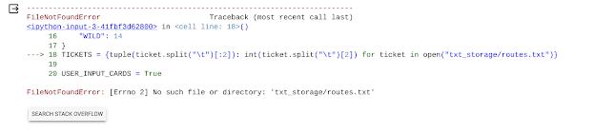
- Instead I’ll figure out the rest of the heuristics to add, because I’m going to have to do that anyway
  - Have added: dist_left_to_span, hand_objectively_better, distance_reduction, cards_away_from_ticket (not working), min_dist_between_cities, find_longest_route_starting_at_city, find_longest_route, has_connection, calc_ticket_points (not including BAD_cards_away_from_ticket, the one with something like O(10^2^3^n))
  - Want to add (actual methods are in pink highlight): cards_away_from_ticket_change, longest_route_change (points gained from gaining longest route if we make this move) (wouldn’t account for other players losing points—it’s probably not worth the time it’d take to do so), points_gained_from_playing (points gained directly from taking this route, if it’s a route), ticket_point_change, num_trains_played (for value-of-a-train-car calculations), ticket_taking_boost (if taking a ticket, the number of train cars the lowest player has left, minus some giant number if tickets not all done), tickets_all_done, taking_locomotive (1 if the move is to take a face-up locomotive), average_CAFTC (expected cards_away_from_ticket_change for a deck card)
Here is the least complicated heuristic function calculation (if I have time, I’ll improve on this later on, but these are the values that absolutely need to be in the heuristic for things to work):
value_of_move (higher is better) (notable things in pink highlight, explained below) = sum(A * distance_reduction for each ticket) + B * longest_route_change + C * points_gained_from_playing + D * ticket_point_change + sum(E * cards_away_from_ticket_change for each ticket), if taking card - F * num_trains_played + G * (ticket_taking_boost - H) - J * taking_locomotive + K
- F * num_trains_played is negative to penalize the player for not wasting trains
- G * (ticket_taking_boost - H) means that ticket_taking_boost can be trained to be negative if H is large
- J * taking_locomotive is negative to penalize the player for spending the entire turn on taking a locomotive
- K is the default value of some throwaway move that does absolutely nothing
- The following values are based on ‘how many points would I expect this value to get the player’:
- Initialize A around the range (0, 2)
- Initialize B around the range (0, 2)
- Initialize C around the range (0, 2)
- Initialize D around the range (0, 2)
- Initialize E around the range (0, 1)
- Initialize F around the range (0, 3)
- Initialize G around the range (0, 2)
- Initialize H around the range (8, 35)
- Initialize J around the range (0, 1)
- Initialize K around the range (-5, 5)
- We also talked about college stuff

Biggest Heuristics

1/30/2024
- Was out today

1/29/2024
- Plan: Fix cards_away_from_ticket method!!!
- I broke my computer and as far as I know, school chromebooks don’t have an API installed. Tried to use Google CoLab but couldn’t figure out object-oriented programming with it
- Wrote email to Dr. Yilmaz:
Hi Dr. Yilmaz,

I hope you're having a good day so far! I broke my personal laptop and am now trying to use a school chromebook for code, but I can only use Google CoLab and I don't think the object-oriented uses of Python will work with it (my project has each bot be its own special object). What should I do? Do you have any suggestions?

Thank you!
Cameron (p. 4)
- After Dr. Yilmaz got here, she had to talk to Ven first. It’s lasted until the end of class—I’ll talk to her tomorrow

1/25/2024
- Presentation and party day today!

1/23/2024
- Plan: Fix cards_away_from_ticket method!!!
- I was absent today

1/18/2024
- Plan: Test and fix cards_away_from_ticket method; prep presentation and milestones
- Cards_away_from_ticket was being grumpy
  - Bug 1: I had to make a copy of a list so it wouldn’t accidentally recur forever
  - Bug 2: I had set something to None instead of 0
  - Bug 3: My data structures were depending on each other too much
  - Still not working! I’ll figure out what’s wrong and fix this next time
- Done updating presentation and milestones! Coding heuristics is taking longer than expected (because of breaks and snow days, we’ve also only had five class periods since the last presentation, one of which was an anchor day) but it’s moving along

1/11/2024
- Plan: Make cards_away_from_collecting_ticket method that is for just one already-established route
- Changing dist_left_to_span so it stores and returns this “best” route to take—done and working! (tested this on real routes, too)
- For cards_away_from_ticket, almost done writing it (it’s a whole new method, not an adaptation of an already-existing method)—will test once it’s done!
- Was able to finish the method in class, but just at the very end of class—unable to test

1/9/2024
- Plan: A bit more testing of dist_left_to_span, then maybe a cards_away_from_collecting_ticket method? Something that would work a bit like dist_left_to_span but subtracting how many cards the player has of a given color—this would be useful for determining which cards the bot “wants” to draw
- cards_away_from_collecting_ticket:
  - Making different entries in priority queue for taking routes with different colors—for parallel routes, add an entry to the priority queue for every color in the parallel routes; for gray routes, make an entry for every single color (yes, really… oh boy) (as far as I can tell, this is the only way that’s not extremely convoluted to make the method actually spit out the right value)
  - Also have to make a method called hand_objectively_better to assess whether a given hand is “objectively better” than another one (“objectively better” meaning it has more of or the same amount of every card—i.e. there is no possible way that the other hand could be better than the given hand)
    - This way I can account for the possibility that the distance “thus far” is higher (we used a card option that we have less of) but that using the other card option that we have less of is actually better in the long run because we need the other cards more. In this sort of scenario, the distance being higher to this point is not enough to rule out another route to the point being worse, as long as this point isn’t the endpoint.
    - I then need to change cities_found to a list instead of a dictionary, have it store each hypothetical hand that we get when we go to this city, and keep progressing from there.
  - We’re going to play a fun game called ✨is this adjustment going to make the function have insane time complexity✨ (the worst case big-O is absolutely terrifying)
    - Because gray routes make the algorithm cycle through every possible color, worst-case big-O of cards_away_from_collecting_ticket is something like O(number of colors^number of links it takes to get the ticket), and that’s without accounting for the BFS part of it. That’s something like 10^6 in the worst case, without accounting for BFS. I guess we’ll see if that worst-case actually happens enough to show up and make a difference… (although I guess lists of 1000 have O(n^2) operations on them that aren’t horrible)
- First attempt at testing cards_away_from_collecting_ticket: I botched two things in the first 6 minutes of plugging things into the console. Note to future self: don’t try to test this with the app when sleep-deprived.
- Going to test cards_away_from_collecting_ticket with just console
  - Bug 1: wrote ‘possiblecol’ instead of col
  - Bug 2: forgot an elif instead of an if
  - Denver-El Paso (short route of gray) was fast, but Duluth-Houston (longer route of gray) took much longer. I’m going to have to simplify this method—I’m going to go with just selecting the three colors with the most cards
  - Bug 3 (after change): selected number of color instead of color
  - Bug 4: didn’t put extra parentheses for tuple
  - Bug 5: didn’t do that in both places it was necessary
  - So, it was correct, but it took like four seconds to output. I’m going to select two instead of three colors, and I’m going to be careful about where I implement this. Now, worst-case is O(2^n), with n being like 4 on average—not great, but optimized, unless I care to just store the best route and try and get the bot to go for that best route regardless of its luck (i.e. make the bot more stupid).
  - Looking at the best two colors instead of three for gray routes, it was much faster, as expected (mathematically, that one should have been (3/2)^5 = 7.6 times faster, which tracks). It’s still a noticeable split second to output, though, which is not great. I’m going to try with a few cross-country worst-case routes to make sure they aren’t insane (Duluth-Houston had five gray routes up against each other, which was a very bad scenario). Trying Vancouver-Montreal, Seattle-New York, Los Angeles-New York, and Los Angeles-Miami.
  - Oops.
  - Dist_left_to_span is perfectly fine traversing the whole board, but because cards_away_from_collecting_ticket grows exponentially whenever it stumbles across either a gray route or a parallel route, it is pitiful with trying to go across the whole board
- In conclusion: Today was a fun experiment!! I’m not doing this horrible cards_away_from_collecting_ticket method because parallel routes and gray routes and the potentially-better-cards part add up to make it absolutely hellish and packed with exponential big-Os on top of exponential big-Os on top of exponential big-Os! I guess the bots will not be that smart at considering alternative routes besides the one they want based on dist_left_to_span!

1/8/2024
- Plan: Write code for Task 3 (see 1/4/2024 entry), then test Tasks 2 and 3 together in an actual game simulation
- Distance reduction seems to work! Distance reduction of Los Angeles to Chicago when playing Dallas to Little Rock = 15 - 14 = 1.
- Bug where instead of crashing, the dist_left_to_span method just keeps running forever if the city entered is not on the board: fixed so now it just returns None

1/4/2024
- The Plan: (to make a heuristic to decide which route to take to connect two cities)
  - Task 1: Using BFS, make a method to find the minimum distance from any given city to another. Test this method before moving on to Task 2.
  - Task 2: Make a new method by copying the method from Task 1 and change it so the distance traversed (when traversing any route that this player has already claimed) is 0.
  - Task 3: Make a distance-reduction method that takes in a tuple for the ticket cities and a tuple for the pair of cities that some hypothetical move would be claiming.
  - After these tasks, I can lump this into some greater heuristic function that incorporates length of the prospective route and which cards it takes and whatnot.
- Results:
  - Task 1: Mostly working but had some bugs. Fixed a bug where it wouldn’t care if it found another route that was better (I used a set to store traversed cities instead of a dictionary with best route lengths). Fixed another bug where it wasn’t adding the new length to the original length. Now it works wonderfully!
  - Task 2: Wrote code that I think will work, but haven’t actually tested it yet (I’ll need to do it inside an actual game simulation).
  - Task 3: Since 3 just uses 2’s code, I’ll test them both at the same time and do 3 before testing. Have just gotten here at the end of class; will do this and test next class.

1/2/2024
- Brainstormed ways of going forward! What I plan to actually do (the best option) is in bold
- May make a method for RandomBot to determine the route it wants to take (this will have no impact on the actual decisions RandomBot makes, but I still want to make it before making “smarter” bots) to achieve each ticket. Create some sort of (trainable, in the future) parameter for the expected value of a train car.
  - Have the bot determine the shortest route?
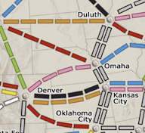
  - Route that gets the bot the most points while still preserving the most train-car-expected-values. I might need to modify this as I go, but this could be a good first step for the code
- It might be both easier and better to instead use metrics of how many train cars are left in each route. For instance, if we had our route as Duluth-Oklahoma City (pictured on the right), we’d currently have 5 cars left to play in the route, but playing on Omaha-Duluth would mean we’d only have 3 cars left to play in the route; this change could give us a higher “utility” value for that play. (If I can manage to include all of these sorts of things in the utility function, there’s a lot less to code and it’s a lot neater. That sounds like a good idea.)
  - I also could use some sort of way to account for the fact that taking Denver-Omaha is marginally better than Denver-Kansas City (it would make it easier to get Duluth-Oklahoma City and would get more points in the process). If we take Denver-Omaha, we’d be 6 trains from the route if we were forced to incorporate both Denver and Omaha. If we take Denver-Kansas City, we’d be 7 trains from the route if we were forced to incorporate both Denver and Kansas City. So minimizing (distance from city1 to ticketcity1 + distance from city2 to ticketcity2) is what we want to do with this contribution to the utility value.
    - Thinking about this more, this isn’t really that useful or necessary. I could add this sort of functionality if I have time, but it’s not necessary—this could be part of that step of “making better bots that account for more things”
  - I’ll definitely need a function that finds the smallest distance from one city to another, presumably with a BFS algorithm.
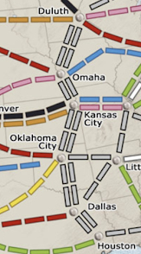
  - With that function, I can use “distance reduction” as part of my heuristic function of how good it is to take a route. Distance reduction = max(0, current_distance_between_cities — new_distance_between_cities).
- But what if we had Duluth-Houston as our route and we’d already taken Omaha-Kansas City and we were evaluating distance_reduction for Oklahoma City-Dallas? What would be the algorithm?
- New idea—I make a method very similar to distance-from-one-city-to-another called distance-left-to-span that finds the smallest distance from one city to another, presumably with a BFS algorithm, but with the cities on the other end of already-claimed routes simply denoted as 0 units away from the original cities. That works perfectly for all the bugs and nuances I had already been thinking of, and it’s perfect for my distance reduction function!
- The Plan: (to make a heuristic to decide which route to take to connect two cities)
  - Task 1: Using BFS, make a method to find the minimum distance from any given city to another. Test this method before moving on to Task 2.
  - Task 2: Make a new method by copying the method from Task 1 and change it so the distance traversed (when traversing any route that this player has already claimed) is 0.
  - Task 3: Make a distance-reduction method that takes in a tuple for the ticket cities and a tuple for the pair of cities that some hypothetical move would be claiming.
  - After these tasks, I can lump this into some greater heuristic function that incorporates length of the prospective route and which cards it takes and whatnot.
- Started working on distance function

Bug Fixes and Display

12/14/2023
- Party and presentations

12/12/2023
- Plan: fix the bug where the bot thinks it can take a route parallel to a route it already took, then move forward with other stuff! There are also going to be presentations—I might present and might not, and that might also mean I can’t fix the bug or start developing strategy parameters
- I’ve fixed the parallel route bug! I also adjusted my presentation some more to better accommodate Dr. Yilmaz’s guidelines for what the presentation should look like
- Plans moving forward (tweaking previous ideas I’ve written down):
  - Method for bot to determine the route it wants to take to achieve each ticket. Create some sort of (trainable, in the future) parameter for the expected value of a train car. Have the bot determine the shortest route?
    - Route that gets the bot the most points while still preserving the most train-car-expected-values. I might need to modify this as I go, but this could be a good first step for the code
  - Create smarter bots one by one, adding more parameters as I go (since I’m not sure how long each parameter will take to add)

12/11/2023
- Plan: fix bug, send rest of images and put them here, move forward with other stuff
- Images are below!
- I fixed up my slides and added this time-lapse-esque thing to them! It should be a good display of just how bad the RandomBots are
- I also updated my milestones to reflect my progress (since I’ve now created a display, which I hadn’t done until now), and I added a new highlighting scheme for future steps regarding which steps depend on which other steps
Images of RandomBot play in chronological order:
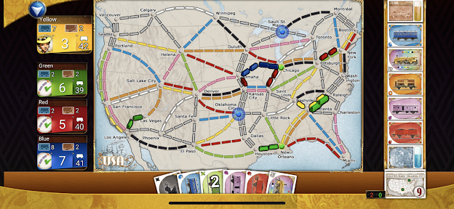
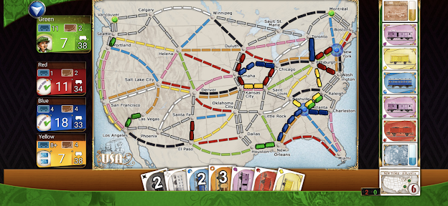
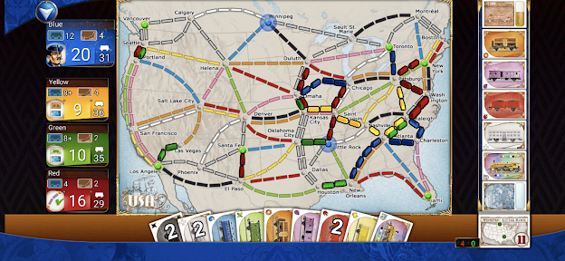
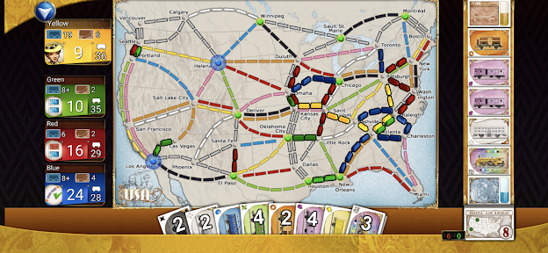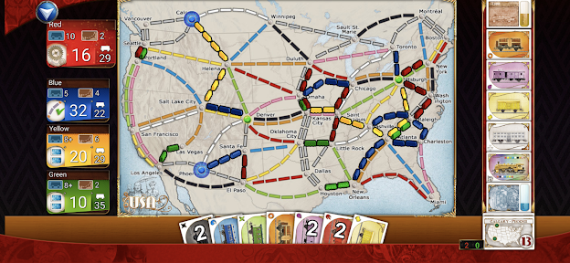

12/7/2023
- Updated my presentation and milestones with what I’ve done!
- Updated the new-tickets method once again (I made it so it generally takes one ticket rather than two, so it’s more similar to what most players do)
- I got some photos of the bots playing when it was actually pretty far into the game! These will do nicely for demonstrating how the RandomBots are. The problem is, I found a bug where the bots think that a route parallel to the route they just took is still open for the taking—it’s open for other bots, but not this bot! I’ll have to address this next class, because class is pretty much over now.
- I tried to send the screenshots to myself so I could put them here, but the reception is pretty slow, so I only got a bit. Reminder to future me to send the rest and put them here!

12/5/2023
- We discussed and organized logistics of the potluck
- Tested out—the rewritten method seems to work!

12/4/2023
- Wasn’t here

11/30/2023
- Plan: keep testing out integration with console/app, particularly for taking new tickets (I need a bit more assurance that it’s all working)
- It turned out my entire take-new-tickets method was messed up and convoluted! It was going to be an absolute mess to fix, so I just rewrote it.

11/28/2023
- Continued to test out the integration with the console and the app, finding bugs
- First bug I found: it wasn’t removing the cards from the face-ups when a bot took one of them 💀 (it was appending them instead of replacing them) (fixed)
- Second bug: it still appended them when they were locomotives (fixed)
- Third bug: referenced this dictionary before assignment (fixed—I’d copy-pasted the wrong stuff)
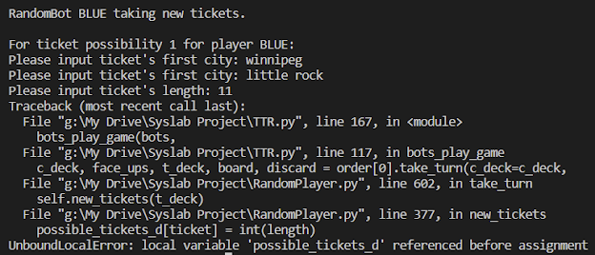
- I’ve produced some early-game screenshots of the RandomBots playing (these are early-game because they’re prior to bugs coming up)
- The first screenshot is the one from somewhat later in the game (even though the same number of trains have been played, you can tell because everyone has a bunch of cards and you draw two cards per turn)
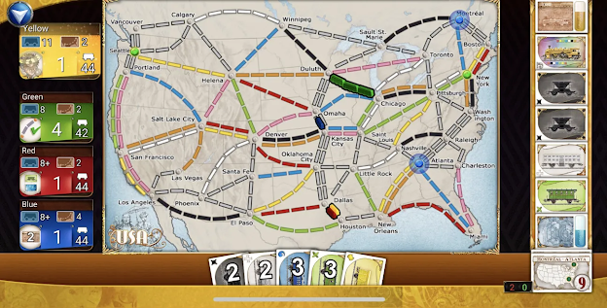
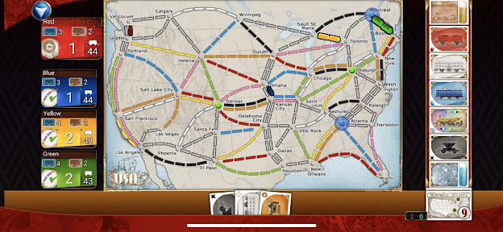
- I’m not confident that it all works yet, but I have successful experiences of every possible case working, so I’m close?

11/27/2023
- Plan: keep fixing bugs in the code to have the user input cards so I can visualize what’s happening with the app (so the app is what RNGs cards and not the code)
- Fixed Bug 5 from last time: had code ask for which face-up cards are initially up
- Other bug: messed up the face-up-cards data structure (should work now)

11/21/2023
- Plan: finish Task 1 (having the user input which cards are drawn, so I can use the app with my program and visualize what the RandomBots are doing)
- I’ve fixed the take_turn method! I’ve also found a thing where this stuff doesn’t work if there aren’t any more cards to draw, and I think I’ve accommodated that possibility in my code. It’s time to try it out!
- Bug fixing time!
  - Bug 1: fixed problem where it wasn’t automatically capitalizing the first letter of the cities in the tickets
  - Bug 2: fixed problem where it didn’t iterate properly for capitalizing Santa Fe
  - Bug 3: fixed problem where the app would only semi-randomly select a start (got rid of randomness)
  - Bug 4: fixed problem where code would only output the decision after asking for follow-up information
  - Bug 5: the code doesn’t ask for which face-up cards are initially up. …except I didn’t fix it because I couldn’t find where in the code it gives face-up cards (💀) (I’ll find it next time!)

11/16/2023
- Plan: finish Task 1 (having the user input which cards are drawn, so I can use the app with my program and visualize what the RandomBots are doing)
- Finished Task 1 with the exception of fixing the take_turn method to accommodate this (I’ll do that next time)

11/14/2023
- Plan: get started on Task 1 (having the user input which cards are drawn, so I can use the app with my program and visualize what the RandomBots are doing)
- Added presentation and milestones 1 to Drive
- Added functionality to enter cards for starting values

11/13/2023
- Plan: see if I can make sense of the Java code to display the board. If not, I’ll work on functionality to have the player play against the bot
- I’ve looked through the Java code, but most stuff is pretty Java-exclusive and I’d have to essentially learn the entirety of how to do graphics with Python. Imo my plan to input cards and whatnot is better
- Ideas for moving forward:
  - Method for bot to determine the route it wants to take to achieve each ticket. Create some sort of (trainable, in the future) parameter for the expected value of a train car. Have the bot determine the shortest route?
  - Create smarter bots one by one, adding more parameters. Multiplier for number of green cards in hand
- I did some reading and read the whole paper by the professors. This is only briefly mentioned, but they didn’t actually use the Ticket to Ride board! So then, reinforcement learning is theoretically open for my project, because they only used reinforcement learning with the following very simple board:
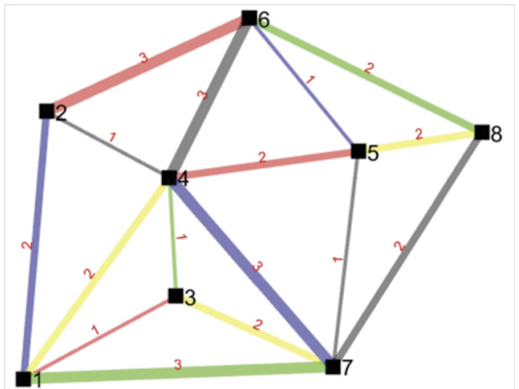
- So then, a big part of me wants to just make a neural net and have it train that with some reinforcement learning, but the computational cost of that would be insane. It’s still difficult and I’m still moving forward with planning, but this means I have more options for my project.
- The Plan:
  - Task 1: Make a console-utilizing method to have the user (me) input game state info (specifically, cards and tickets drawn). Try having some RandomBots play against each other using this; get images of what the RandomBots did for presentation purposes.
  - Task 2: Adapt this console-utilizing method to incorporate the user as a player. Create a UserPlayer class and have it ask for console input, so the program can now fit users playing against the bots.
  - Task 3 (can be before Task 2 if necessary): Make a new bot, ParameterBot, with the goal being to give it some very basic parameters to determine the “desirability” of a game state and use that to rank moves. As time allows, I’ll add more and more parameters to this bot.
  - My guess is that I’ll finish Tasks 1 and 2 by winter break and maybe get started on Task 3.

Traversal and Perfecting Game

11/9/2023
- Plan: Find bugs in gameplay method, ensure tiebreaking works, add ticket display
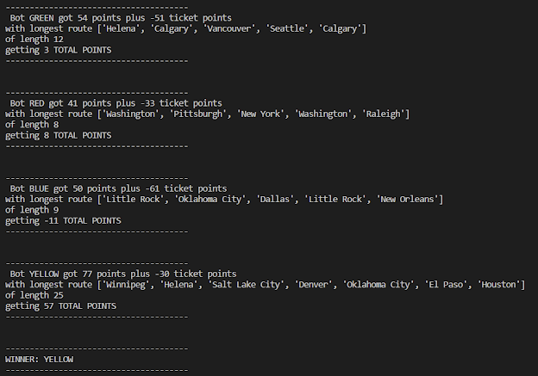
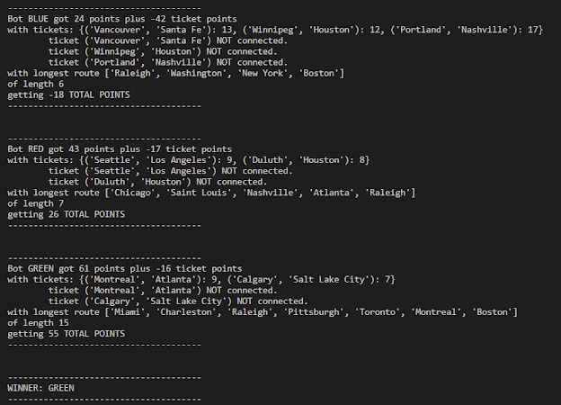
- Everything seems good… I’m proclaiming the traversal and bots-playing-against-each-other all done!

11/8/2023
- Plan: See if I can fix algorithm to find longest consecutive train route
- I added a deepcopy thing and it fixed the issue! And it looks like Past_Cake managed to get the overall length thing right, too. I’m going to do more experimentation with it to make sure it works
- It works! I also just made a (fully functional, I think? Including turn order?) tiebreaker mechanism—next step is to test it out a whole bunch of times to see how it handles ties!
- I should also have it print which tickets the bot had at the end of the game
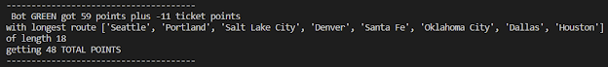

11/2/2023
- Plan: Fix algorithm to find longest consecutive train route by the end of class
  - Bug 1: turns out adding a tuple to a list just adds both values to the list rather than the tuple. Fixed to make it a list of a tuple
  - Bug 2: I made a typo and wrote pair[0] instead of city
  - Bug 3: tried to pop several times to get the same value
  - Bug 4: tried to concatenate list + string to list
  - Bug 5 (unrelated): got grumpy when face-up pile couldn’t take cards from draw
  - Bug 6: forgot to implement Bug 1 fix on the second part of the code
  - Bug 7: implemented Traversed as a set of tuples but needed an extra set of parentheses when defining it
  - Bug 8: added individual cities to Traversed instead of tuples
  - Bug 9: had to iterate over range(1) to finally get a set of tuples working
  - Bug 10: same typo as for Bug 2 but in a different place in code
- After all 10 bugs, the longest consecutive train route method worked! (It was a really-complicated-data-structures-filled BFS with a bit of necessary brute-force iterating through starting cities and finding the longest route starting at a given city—but it worked!!)
  - HOWEVER—I forgot to account for the length of the individual routes involved 💀. I now need to fix that and make it count the total length of the path, not the number of city connections it uses
    - I got this working, I THINK, but I also had another error (screenshot below). Will address next class
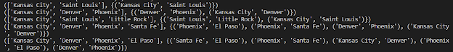

10/31/2023
- Wasn’t here today

10/30/2023
- More presentations
- Implemented BFS algorithm, then tested and found bugs in it
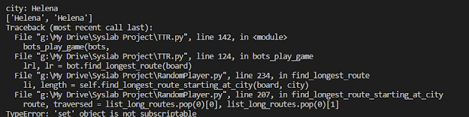

10/26/2023
- More presentations
- Dr. Yilmaz’s idea: potentially see if I can adapt Java code to show what’s happening graphically for the simulation?
- Wrote BFS-esque algorithm to find the longest consecutive train route
  - Didn’t get time to test it—will test it on Monday

10/24/2023
- Added photos of results to slideshow
- We had presentations again today
- Heuristic function idea: rough northernness measure and easternness measure for cities (these thus let the bots account for location)
- List of ideas of factors to include in heuristic:
  - + TRAINABLE (init. normal dist. centered at 0, standard dev TBD) * Northernness (avg. northernness of cities involved in move, if playing trains)
  - + TRAINABLE (init. normal dist. centered at 0, standard dev TBD) * Easternness (avg. northernness of cities involved in move, if playing trains)
  - + TRAINABLE Heuristic for overall hand quality following move
    - (probably not): - TRAINABLE * Number of locomotives this move involves playing
    - (probably not): + TRAINABLE * Would_have_extra_cards_of_this_color_after_playing?
    - Factoring in what routes you want to play, and maybe factoring in alternative nearby routes (although that would be harder/an extension)
      - Involves creating a plan for routes to play: could have the bot have a list of routes they want to play
        - The most complicated part is going to be the nuance of this plan. It won’t necessarily be the shortest path: I might want to code something to guess at how many points the bot will get with the remaining train cars if it takes a given path. This will most likely also be trainable?
- For mutating the trainable values, I want to shift existing values, not necessarily just regenerating values. I could kinda emulate gradient descent (if a player did worse, their values get mutated by higher random values)
  - I could also say something like chance_to_regenerate = 0.1 or 0.2 or something, which I could set manually based on my intuition as to what would be most helpful

10/23/2023
- Worked on slideshow
- Google Drive was finicky today

10/19/2023
- Wasn’t here today; I was sick
- Worked on updating milestones and slideshow

10/17/2023
- Presentations will be on Monday. I’ll update the presentation and the milestones on Thursday—that could take anywhere from ten minutes to an hour and a half, so I’ll do that first and then work on the project in the remaining time I have
- Searching for other bugs
  - Fixed two minor bugs, but it doesn’t seem like there’s anything more in terms of bugs
- Will add a longest_route variable as well to go alongside open_points and ticket_points for winner-calculating purposes
- Now I’m going to work on the graph-utilizing methods: seeing whether tickets are satisfied, and finding the longest route someone has
- Coded a method to traverse the board and find if someone has connected a given two cities, using DFS. The problem is, it exceeds maximum recursion depth very quickly
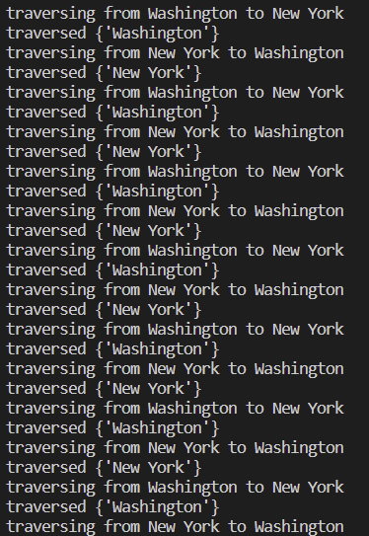
- Oops—I forgot to pass traversed as an argument for the recursive DFS method.
- Seems to be working from initial inspections! It says Yellow goes four times in a row at the end, though, so that’s another bug
  - Fixed that
- Seems to be working smoothly!
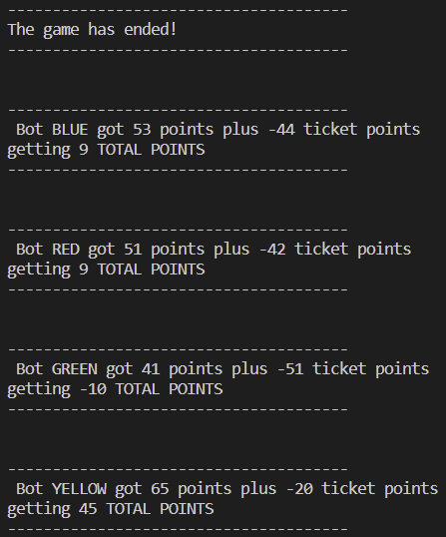
- You can see the bots do pretty abysmally (Yellow’s run here was actually way better than most), but that happens when you don’t get any of your tickets…
- Reviewing my plan from earlier:
  - 1. Figure out that bug from last time
  - 2. See if there are any other bugs, fix them
  - 3. Create code to find if a player has connected two cities! (for tickets)
  - 4. Create code to find longest train route and the player(s) who have it
  - 5. Implement tiebreaker mechanism
- So I’m ahead of schedule! (I was expecting connected-two-cities to be much more painful, I guess.) I’m going to get some water and then see how far I can get on creating code to find each player’s longest train route. This will probably be harder—I’ll have to start from every city and probably do a BFS, because it has to be exhaustive. There might be a creative, less complicated solution to this, though? If only I were creative…
  - I considered only starting and ending at cities where there’s an odd number of routes claimed by this player that exit out of the city, but then realized closed loops count too
  - I also considered having another method to make a list of “webs” of cities that the player has and then doing this above thing if a web has at least one odd-number-of-routes city, but that doesn’t seem helpful
    - I think just brute-force will be the best scenario for this, LOL

Gameplay

10/16/2023
- OVERARCHING PLAN for this week:
  - 1. Figure out that bug from last time
  - 2. See if there are any other bugs, fix them
  - 3. Create code to find if a player has connected two cities! (for tickets)
  - 4. Create code to find longest train route and the player(s) who have it
  - 5. Implement tiebreaker mechanism
- (My plan and tentative goal is to get through 1-3, but maybe I’ll get time to work on 4)
- Getting started with bug fixes and finding new bugs!
  - When it discards the locomotive-including face-ups, the data structures were getting grumpy and it wasn’t conserving the changes. Changed the method to return something and now it works fine. The bug is fixed—#1 is done! It’s 1:28 now, so I’ll start on #2 and hopefully #3 next class.

10/12/2023
- Full-game method! More bugs!
- Limitation that I’ve been thinking of for a while: with 2/3 players you actually can’t take parallel routes. I felt accounting for that would take too much time and also confound which bots may be “better” (bots that go for more areas with parallel routes, maybe)—a user would probably want to play several bots at once, so I want to just focus on games where you can take parallel routes
- Full-game method is DONE!
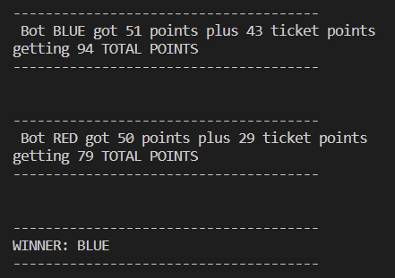
- Tried running with four bots, but coincidentally resulted in a tie:
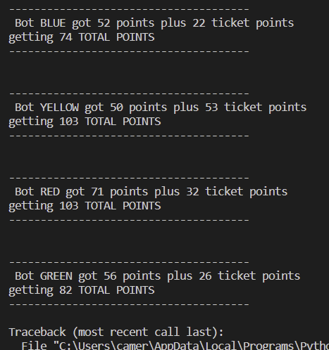
- https://boardgamegeek.com/thread/21131/tiebreaker-question for tiebreaker: first is # train cards completed, second is longest consecutive path; if still tied, the player to have gone later in the order. I didn’t want to implement this last one because it didn’t seem like an efficient use of my time, but I have to, because otherwise the algorithm I use (with many, many games) will get grumpy
  - But at least it works okay with more than two bots, too!
- Stumbled across someone listing the more obscure rules of Ticket to Ride: https://www.reddit.com/r/boardgames/comments/1v2iy5/rules_question_ticket_to_ride/
  - I can verify all of these from personal experience, I’d already incorporated the second, and the third was really easy to implement, but it was still good to know and the first is going to take a little bit to implement (if there are three locomotives face-up, all face-up cards are discarded and replaced)
  - Implemented all three of these! But now class is over
    - Well the one time I did get to try it, it said almost the whole discard pile (like 60 cards for some reason) was WILDs, so something is wrong. Leaving off there!

10/10/2023
- Got here ten minutes late because of Open Forum, another ten minutes were for Jiwoo’s presentation, another eight minutes were for Dr. Yilmaz to discuss flowcharts/UIs, and another seven were to go to the bathroom. I now have five minutes left in the period
- Kept going through full-game method to find more bugs

10/5/2023
- Plan: finish discard pile, finish debugging full-game method
- Sorted out two more bugs (remove() method only removes one instance and another thing that I already forgot even though I solved it literally 10 minutes ago. I am writing this bullet point at 3:02 PM. 🎉)
- Sorted out a truly devious bug where it would let you use wilds you just played to fill in a route
- Sorted out a bug in adding to discard pile
- https://m.media-amazon.com/images/I/B19d+VcYwWS.png - very helpful for checking routes
- Didn’t account for face-ups being empty. Just wrote in special cases for where face-ups/draw are empty (it’s possible, even if the discard pile’s functioning properly)
- Altered RandomBot playing to make it more likely that it will play trains because it was frustratingly long to play trains (also made it a function of how many trains were left so it’d stop saving up cards at the end of the game, because that interfered with functionality, too)

10/3/2023
- I found a paper on reinforcement learning for Ticket to Ride: https://ieeexplore.ieee.org/abstract/document/10154465
  - This is different people, but it was done by nine professors working together and produced an extremely successful model. This suggests that doing reinforcement learning would be an extremely difficult endeavor for me to undertake, especially considering the paper written by those two students on the difficulty of reinforcement learning. Counterintuitively, the excellent performance of reinforcement learning for Ticket to Ride could be a drawback for using it with a bot: if bots consistently beat the players themselves, it would also not be optimal (we want a bot that can beat the players relatively often but not always).
- Going to work on debugging the method to have random bots play games against each other!
  - Made it so it can’t try to take routes that are already taken
    - Didn’t account for parallel routes in this, so that made another bug that I then fixed
  - Made it so it can’t try to take face-up cards that aren’t there (again) (this was the other error that had happened earlier)
  - Fixed bug with remove()
- It is still theoretically possible I may have done something wrong… (see below) (this is sarcasm I definitely did something wrong)
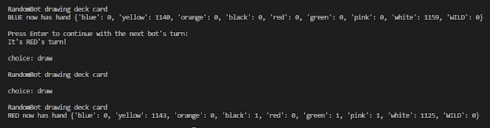
- More bug fixes!!
  - So turns out I got my return statements messed up and some of my functions weren’t giving anywhere to put what they were returning
    - That also meant the num_trains, face-up cards, and deck weren’t updating: it would draw the same cards and playing wouldn’t do anything
  - Fixed a bug with a deepcopy
- I forgot to make a discard pile!! I’m going to do that now
- But aside from the lack of discard pile or ticket points functionalities, working!
- Notes for the future:
  - Make calc_ticket_points() so it has a search to see if two cities are connected - look into graph search algorithms (it’s been like a year and a half since we did this in Data Structures and I forgot them ✨)
  - Heuristic value for loss of playing locomotive
    - Also one for loss of cards that you have a lot of (maybe just a heuristic for overall hand quality? Based on what routes you want to/plan to play, or also maybe factoring in alternative routes to take, although that would be harder? I like this idea of hand-quality-based-on-plan heuristic though)
      - Would also want a small weight for wanting several of the same card (longer routes to just shove in at the end)

10/2/2023
- Impact (for presentation):
  - Ideas:
    - Sell AI algorithm to Ticket to Ride app for them to implement?
    - Alternatives (platforms): I looked through official game/download sites and couldn’t find anything free, but if some Reddit people did it, maybe I can
      - https://www.railbyrail.com/ - Reddit implementation of game
        - This didn’t actually seem like the actual game of Ticket to Ride? I played it for like twenty minutes, and it’s instead like a puzzle game
        - My guess is that the initial game was actually a Ticket to Ride thing but that some copyright thing happened and they were forced to change it? That link now always redirects to a similar-looking but totally different puzzle-esque game
    - I initially didn’t find anything besides what I said, but Dr. Yilmaz found more papers by the same people who had said reinforcement learning isn’t plausible where they actually use reinforcement learning

9/28/2023
- Last presentation
- Plan for today: make the RandomBots play each other!
  - While loop for train counts; loop through turns, console input to keep them from doing it too fast so I can follow whether the game mechanics are working; remember to take last turn
- It was surprisingly annoying to code to find the winner (I decided to figure out the mechanics of a priority queue library because I want to implement that for my heuristic function idea from earlier)
- But yeah I just coded this. I finished coding it!! (I have not tested it yet!!) (at least I did a good job guessing what I’d be able to do!!)
  - Plus added the score mechanic and number-of-trains mechanic to RandomBot
- Tested for like 8 minutes. Errors I got are included below so I don’t forget them

(probably just fixable by ignoring already-claimed routes - ignore when they’re BLUE, RED, etc. as opposed to blue, red, etc., since I denote player colors in all-caps and board colors in all-lowercase)

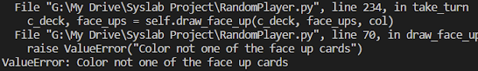
(no clue what’s causing this one, fix other errors first maybe it’ll magically fix it)

9/26/2023
- Presentations
- Idea: heuristic (modify weighting of things in heuristic based on what the bots “like”) - points expected to gain (from playing, for instance, would be points you gain + points of route/number of length of route you don’t have to get anymore + points you miss out on from claiming other routes you could have gotten with those cards… etc)

9/25/2023 evening (9:00-11:00 PM)
- Put together presentation and completed milestones document

9/21/2023
- [Wasn’t here]

Turn-Taking Method

9/19/2023
- Fixed errors on turn-taking method!
  - Draw error fixed (the looping mechanism I used was flawed), face-up error fixed (the choice mechanism I used had a bug), play-trains error fixed (choice mechanism bug), face-up locomotive error fixed (didn’t recognize fringe case)
- So I need it to recognize when the game ends, end the game when that happens… and that’s basically it for now!
- I also need to have it calculate points. It wouldn’t track ticket points until the end of the game, but maybe I could do a ticket point counter as well to see how many points the bot would currently get from tickets if this were the end of the game right now, and just have other bots see the regular point counter but not the ticket point counter (ticket point counter might be useful for utility-esque-finding-things)
- I can test out the RandomBots by just having two RandomBots play: instead of having them both play and be unable to track what the heck is going on, I could have each bot take its turn, then prompt the user to see if they’re ready for the next turn, then continue as such

9/18/2023
- Finished turn-taking method for RandomBot! …but it doesn’t work (lots of errors I am currently working on)
- Notes for the future:
  - Possibility for future bots (like, where it actually matters what they choose to do): make a list of all possible moves they can make, and analyze which move is best? Like a list of tuples with utility values as the second value?

9/14/2023
- Continue making bot-turn-taking mechanism
  - Tested method to play trains
  - Worked more on overall turn-taking method; finish that and the bot can take turns! (randomly, but still)
- Got a couple pictures of sample ways the bots play badly
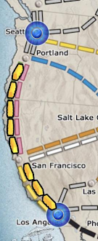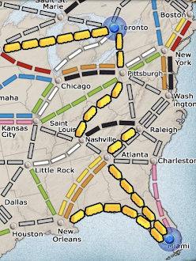
- Discussed with Dr. Yilmaz; board session info below
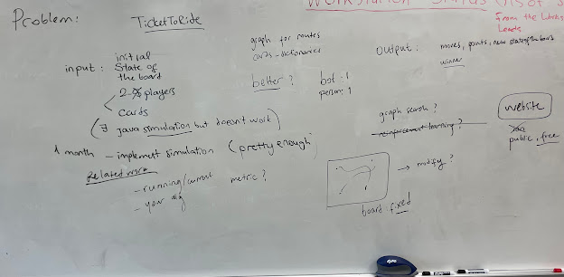

9/12/2023
- Had doctor’s appointment

9/11/2023
- Continue making bot-turn-taking mechanism
  - Make method to play trains (just wrote this, but still need to test it)
  - Already made part of the turn-taking method; finish that and the bot can take turns! (randomly, but still)
- Kat won’t be partnering with me per se, but she said she’d work on it as a side thing
  - Possibility of working with other dev-lab kid (Dr. Yilmaz mentioned this): it’d probably be nice, but my thing is super niche and I don’t want to shove anyone into it

9/7/2023
- Code mechanism for the bot to take a turn
  - Find routes that can be taken
    - Done; checked over with the app (some of this takes a long time to check ✨)
  - Made method to take new tickets
  - Possibilities at start of turn: take tickets, play trains, draw a face-up locomotive, draw a face-up non-locomotive, draw a face-down card
    - If one of the latter two choices: draw another card afterwards (either face-up non-locomotive or face-down)
- Meeting up after school with Kat to discuss project
  - Discuss how the game works
  - Discuss journals
  - Send code - share through Google Drive

Creating Data Structures

9/5/2023
- Adding data structures
  - Connections between cities
    - Finished adapting GitHub file (there were parts of the file that were outright wrong, so I fixed that, too)
- Organized more stuff
- Plans for the future:
  - Will meet up after school Thursday with Kat to discuss project
    - Discuss how the game works, discuss log
  - Next steps:
    - Code mechanism for the bot to take a turn
    - Code mechanism for the user to take a turn (using console, for now)
    - Code play method for the user to input game-state stuff in the console (thus, ability to use the app as a visual)

8/31/2023
- Adding functionality to RandomBot and adding more game mechanics
  - Added card-drawing (deck and face-up)
- Adding data structures
  - Connections between cities
    - Adapted file from GitHub project for this (see excerpt of original below)
    - Didn’t finish this part, but got a decent way through it
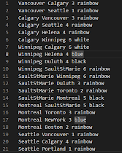

8/29/2023
- Starting by coding the mechanics of the game itself
  - Make a bot that just acts randomly first
- Easier to check by playing through a game against it first: code a keyboard input thing
  - Then for having someone play against it with the game state fed in (having the app RNG cards drawn, etc. and the computer solely make decisions on the part of the player)
    - Test game mechanics are working
  - First for having someone play against it with the computer generating the game state (having the computer RNG the cards drawn, etc)
- Other Solutions page of slideshow: I’ll have to play through a couple games and note ways that the bots are clearly just being stupid
- For decks of cards, do I want to randomly initialize stuff in an ordered list and model shuffling the deck and taking the first card?
  - For now, I’ll stick with no so I can use a dictionary for the deck since it’s easier to store… it won’t impact strategies of any bots, anyway
- Learning data structures and classes
  - https://stackoverflow.com/questions/4142151/how-to-import-the-class-within-the-same-directory-or-sub-directory
- TTR destination tickets data
  - https://ticket-to-ride.fandom.com/wiki/List_of_Ticket_to_Ride_Destination_Tickets

Creating General Idea of Project

8/24/2023
- Conference w/Dr. Yilmaz on TTR idea:
  - Make interface to play it (website)
- More research on TTR idea:
  - Some sources:
    - https://www.eecs.tufts.edu/~jsinapov/teaching/comp150_RL/reports/Nguyen_Dinjian_report.pdf (basically just two people from Tufts who were like “using reinforcement learning is hard for Ticket to Ride” and that was their entire project 💀)
    - https://www.reddit.com/r/tickettoride/comments/vxy4rr/i_built_an_ai_to_play_the_physical_ticket_to_ride/ (someone on Reddit who coded some of the optimizing-path and optimizing-draws stuff but not anything strategic)
    - https://github.com/ss2cp/AI-TicketToRide (someone on GitHub who made a bot… very randomized, with strategy hard-coded)
  - Genetic algorithm possibility, training a bunch of parameters I make that distinguish strategy
- Data structures:
  - Set of cities
  - Dictionary to hold city connections: keys are tuples of two cities, values are tuples with the first value a length and the second value a list of colors (potentially including gray)
    - When taken, change the color to some indication that it’s been taken by some player
  - List of cards in the deck; list of cards face-up; dictionary for each player of each color card and how many they have of that color
  - Dictionary of train ticket cards: keys are tuples (sets are unhashable) of two cities, values are integer lengths
    - One serving as the deck; one serving as the tickets in the player’s hand
- Notes for the future:
  - Potential problem with making an interface: copyright law???
  - Rather than starting with any sort of interface or even running the game itself, use the app as the interface. Allow the app to run the data and whatnot; input what happens into the console on Python.
  - Work with someone from Mobile/Web, otherwise the workload with interface is probably too much
    - Discussing with Kat

8/22/2023
- Today, we introduced ourselves to the class
- Research on the Ticket to Ride idea:
- Reinforcement learning possibility
  - Action space for TTR:
    - Draw cards
      - First card either face-up non-locomotive, face-up locomotive (ends turn), or face-down
      - Then reevaluate, then second card, either face-up non-locomotive or face-down
    - Play trains
      - Whichever routes are possible to play at the moment
  - Observation space:
    - Total points for each player (excluding tickets)
    - Which cards are face-up to draw
    - Which routes have been taken by whom, and which cities they connect
    - Which routes have not been taken and which color they are, and which cities they connect
    - Which tickets the bot has & whether each ticket is complete
- TTR is probably too complex to do machine learning like that… it’s 3:57 so I’ll probably just look into other possibilities next class
- Notes for the future:
- Could machine learning work “too well”? Would I be able to “dumb it down” so it’s beatable by players?

8/21/2023
Today, we discussed rules and the structure of the course, along with the syllabus. Current idea for project: better Ticket to Ride bot?

